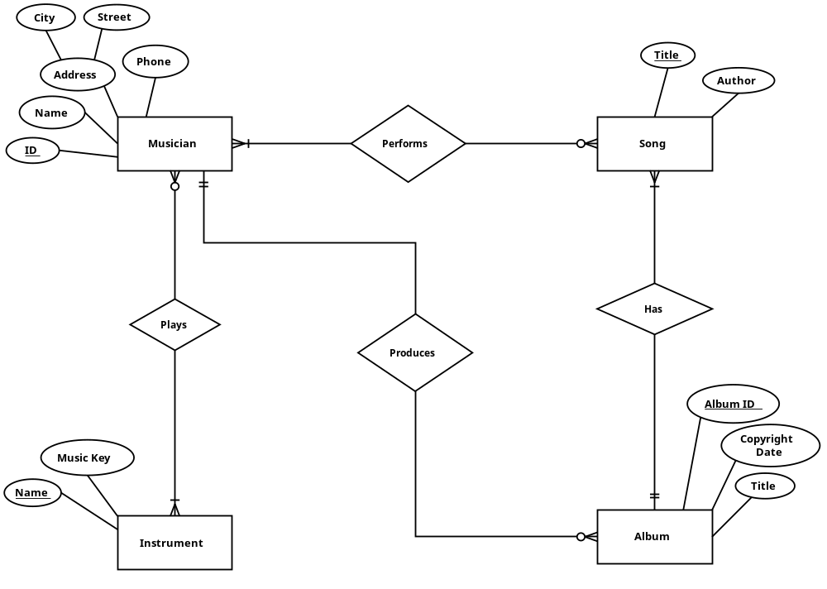
Musician (IRD, name, phone, st, city, country)

Instrument (Name, Key)

Mus_Inst (IRD, Inst_name)

Album (Id, copyright_date, title, producer_IRD)

Song (title, author, album_id)

Mus_song(IRD,title)
Problem 2
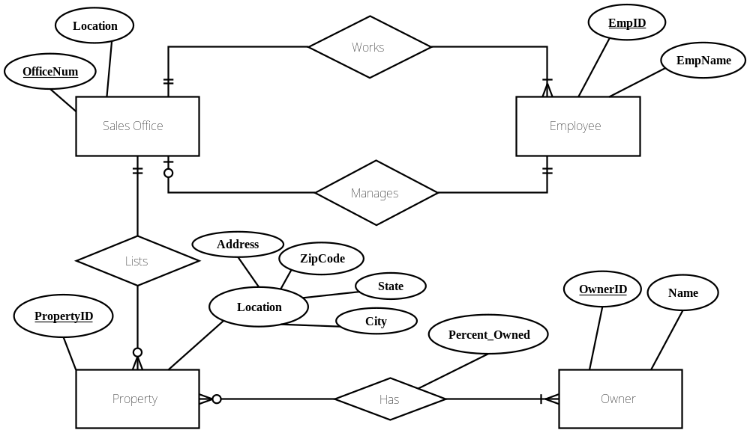

Sales office (sales office_ID, Loc, Manger ID)

Employee (emp_ID, Name , Sales office_ID)

Property (Property_ID, Add, City, State, zip, sales office_ID)

Owner (Owner_ID, name)

Property_owner (Property_ID, Owner_ID, Percent_owned)

Problem 3
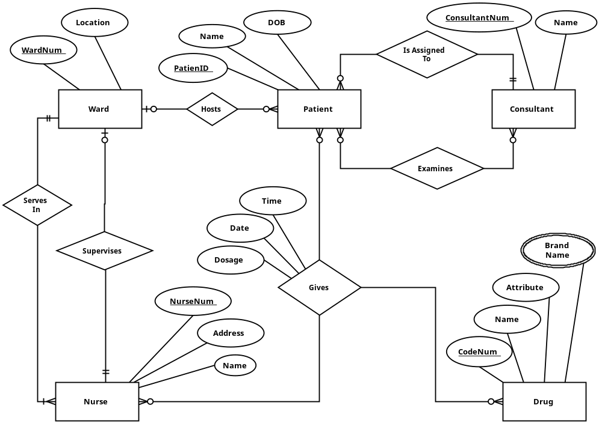

Patient (patient id, DoB, name, name, ward_id, consultant id,…)

Consultant (consultant id , name, …)

Drug (code, recommend dosage)

Drug_brandnames (code, brandname)

Ward (ward_id,name, nurse_num,…)

Nurse (num, name, ward _id,…)

Patient_consultant (patient id, consultant id)

Treatment (patient id, drug code , date , time, nurse_num, dosage)

Problem 4

Airline
ID
Name
Address
Phones
Contact Person
Employee
ID
Name
Address
Position
qualifications
Gender
Birthday
day
month
year

1
Works in
M
Aircraft
ID
Capacity
Model
Transaction
ID
Desc.
Date
Amount
Owns
assigned
Has
Maj. pilot
Ass. Pilot
Hostess1
Hostess2
Records
#passe
Dept/Date Time
Time spent
Arr/Date Time
Route

ID
Origin
Destination
Classification
Distance
Price/pass
1
M
1
M
Crew
1
M
1
M

Employee ( ID,name,position,address,day,month,year,gender,airlineID)
Airline( ID,name,address,contactperson,)
Employee_Qualifications (Num,Qualification)
Airline_Phones(ID,Phone)
Transaction(ID,desc,date,amount, airlineID)
Aircraft(ID,capacity,model,majorpilot,Asspilot,hostess1,hostess2 airlineID)
Route(ID,Origin,distance,destination,qualification)
Aircraft_Route(AircraftID,RouteID,DeptDateTime,ArrDateTime,nopass,priceperpassenger,timespent)

Problem 5

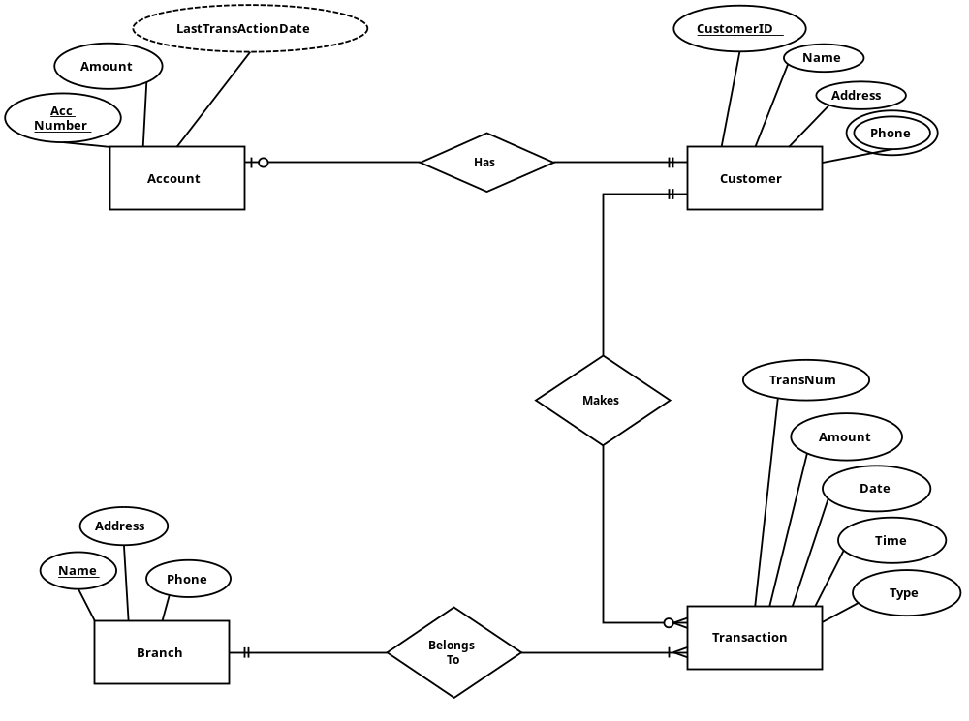
Customer (customer_id, name, address, credit_no, amount, last_trans_date)

Customer_Phone (cust_id, phone)

Transaction (Trans_no, Trans_Type, Trans_Date, Trans_Amount, Trans_time, cust_id, Branch_Name)

Branch (Branch_Name, Add, Phone)

